# Band Manager

A new up-and-coming band, The Shakes, are doing a gig in your town! They have asked the venue to make sure the following items are ready for them in their dressing room (this list is called a **rider**).

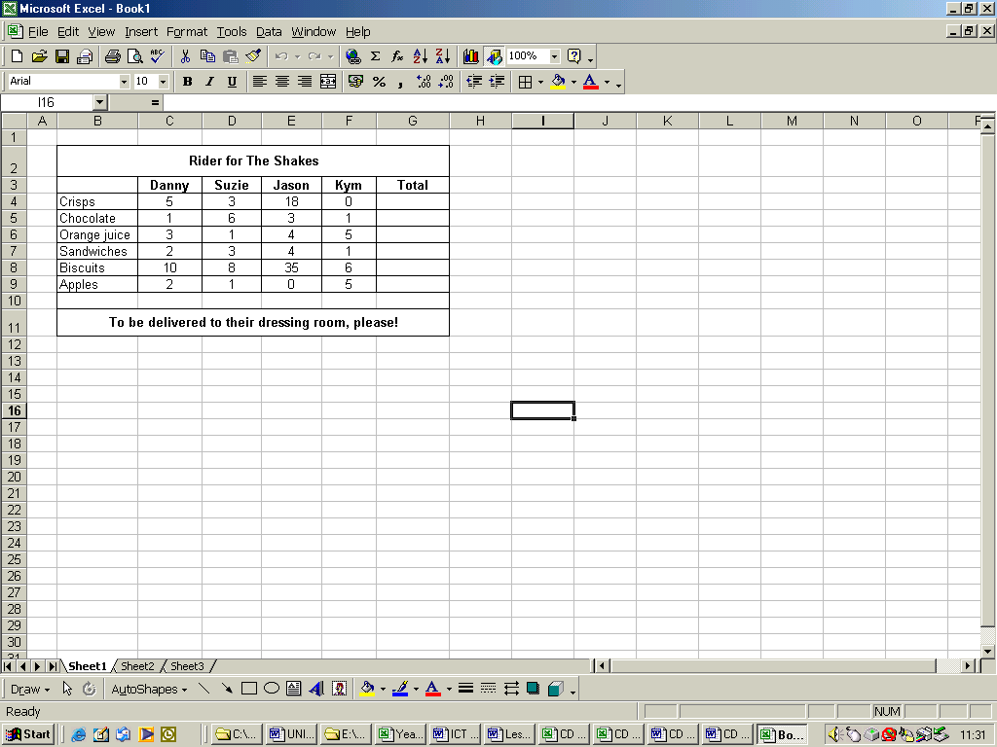



**Activity:** Answer these questions using the screenshot of the spreadsheet above.

1. Which band member wants the most crisps? jason
2. Who prefers apples to crisps? Kym
3. In which cell can you find the highest number on the spreadsheet? Write the cell reference here: E8
4. Does cell F5 contain a variable or a rule? Variable
5. How many sandwiches does the venue need to buy for the band altogether? 10
6. What would the formula be for working out the total number of sandwiches? =SUM(C7:F7)
7. What new column would need to be added so that the venue could work out how much the items were going to cost them? Cost
8. 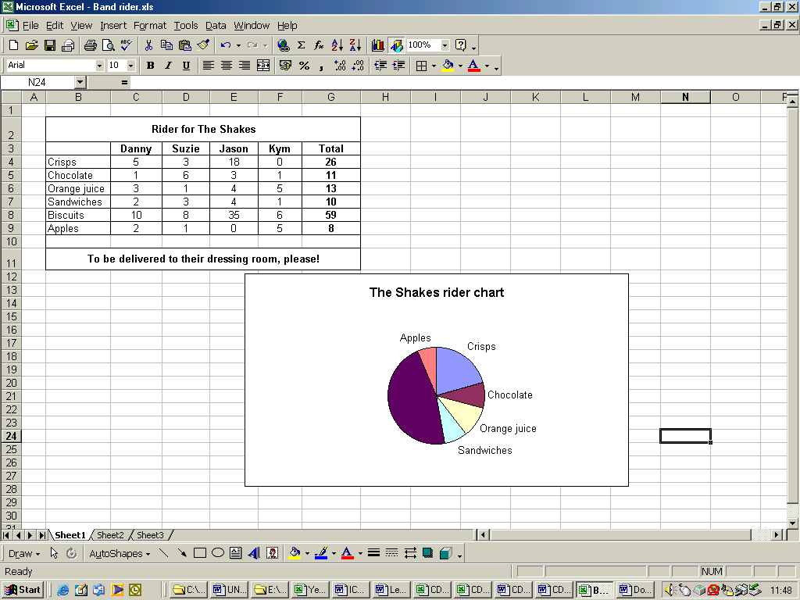There is a data label missing from the chart opposite. What should it read? Biscuits
9. What is one advantage of putting information in a chart like the one shown opposite?

**You an easily see which is bigger**

1. Can you think of one disadvantage?

**You can’t see the exact numbers**